JMST Instructions - Figures
- Format: High-resolution figures must be uploaded during manuscript submission. The preferred format for figure submission is tiff format (*.tif).
- Image Size: An image intended for the journal's double column format (i.e., an image to fit into the space of a single column on the 2-column layout), should be sized to 6.5 cm. Images submitted for a layout that spans full columns (i.e., an image that will occupy the full-page width) should be sized to 13.5 cm, and complicated figures should have a maximum width of 15 cm. In the figures, the main lines should be about 0.3 mm in width, and the assistant lines 0.15 mm. Notations in the figures should be distinct and consistent with the same ones in the text, and their font size will be 8-10 pt.
- Image Resolution: Line drawings and graphs must have a resolution of at least 1200 dpi when they are exported. Photographs and micrographs must have resolution of at least 300 dpi (600 dpi if there is text or line art in the figure). Please use LZW compression (which does not affect resolution) when saving figure files. Lower-resolution images will not reproduce properly and will not be accepted.
- Color: Submit color graphics in CMYK format; the colors chosen must reproduce effectively and the colors should be distinguishable when printed in black and white; The descriptions of figures in text and captions must be sufficiently clear for both online and print copy.
Samples:
1.
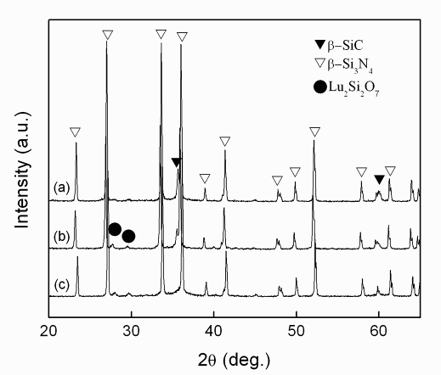
- All ticks should be the inner side of coordinates;
- Titles of coordinates should be with the formula “Quality (unit)”, such as “Intensity (a.u.), 2θ (deg.)”;
- All fonts should be “Arial”;
- Circle type symbols are preferred;
- The graph should be framed with four axes;
- The first letter should be capital for the word in the figures, such as “Current density”.

2. The first letter should be capital for the word in the figures, such as “Corrosion products”

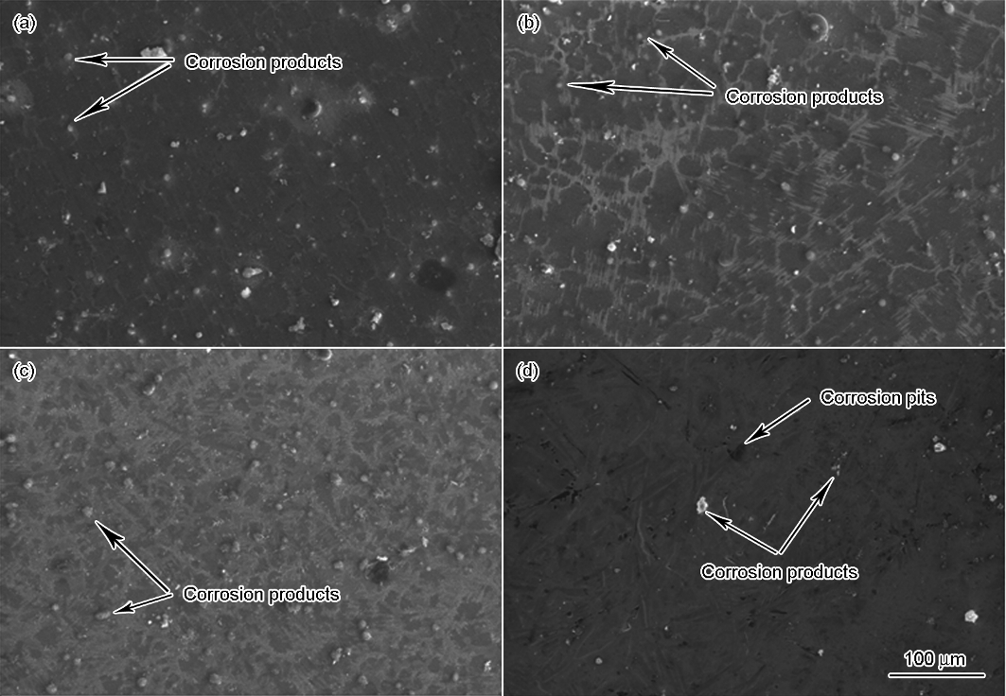

Formats for different references

References to journal publication:
[1] J. van der Geer, J.A.J. Hanraads, R.A. Lupton, J. Sci. Commun. 163 (2000) 51–59.
[2] Y. Zhang, L. Ren, M. Li, X. Lin, H.F. Zhao, K. Yang, J. Mater. Sci. Technol. 28 (2012) 769–772.

References to book:
[3] W. Strunk Jr., E.B. White, The Elements of Style, 3rd ed., Macmillan, New York, 1979.
[4] J.Q. Yu, Atlas of Binary Alloys Phase Diagram, Shanghai Scientific and Technical Publishers, Shanghai, 1983, pp 334–339.

References to a chapter in edited books:
[5] G.R. Mettam, L.B. Adams, in: B.S. Jones, R.Z. Smith (Eds.), Introduction to the Electronic Age, E-Publishing, Inc., New York, 1994, pp. 281–304.
[6] U.F. Kocks, C.N. Tome, H.R. Wenk, H. Mecking, in: Texture and Anisotropy, Cambridge University Press, Cambridge, UK, 1998, pp. 182−183.

Reference to proceeding:
[7] F. Masuyama, L.B. Adams, In: Proceedings to the 4th International Conference on Advances in Materials Technology for Fossil Power Plants, Hilton Head Island, South Carolina, U.S., October 25–28, 2004.
[8] C. Scott, N. Guelton, S. Allain, M. Faral, in: Materials Science and Technology 2005, Pittsburgh, PA, USA, 2005, pp. 127−138.

Reference to dissertation
[9] X.H. Ma, The Preparation and Property Researeh of Hydroxyapatite Flurescent Nano Particle, Ph.D. Thesis, Wuhan University of Technology, 2007. (in Chinese)
[10] K.L. Corwin, A Circularly-polarized, Optical Dipole Trap and other Developments in Laser Trapping of Atoms, Ph.D. Thesis, University of Colorado, 1999.

Reference to patent
[11] C.G. Bai, L. Murr, W. Smith, A Novel Method for Preparing Al Base MMC, US Patent, No. 200101133, 2001.

Reference to online literature
[12] C.G. Bai, L. Murr, W. Smith, http://www.jmst.org/EN/volumn/home.shtml.

JMST Instructions - Mathematics
- Special care should be given to make equations and formulas clear to the typesetter.
- Variables should appear in italic text.
- Vectors should appear in bold italic text.
- Capital and lower-case letters should be distinguished clearly where there could be confusion.
- Fractional exponents should be used to avoid root signs.
- Extra symbols should be introduced to avoid complicated exponents or where it is necessary to repeat a complicated expression a number of times.
- The slash (/) should be used wherever possible for fractions.
- Mathematical derivations that are easily found elsewhere in the literature should not be used.

